Практическая работа 8
Тема: «Эффективность информационных систем»

Цель: научиться разрабатывать простое приложение калькулятора доставки, а также проанализировать его функциональность и эффективность в повышении качества и скорости обработки заказов в системе.

Ход работы
- Дизайн
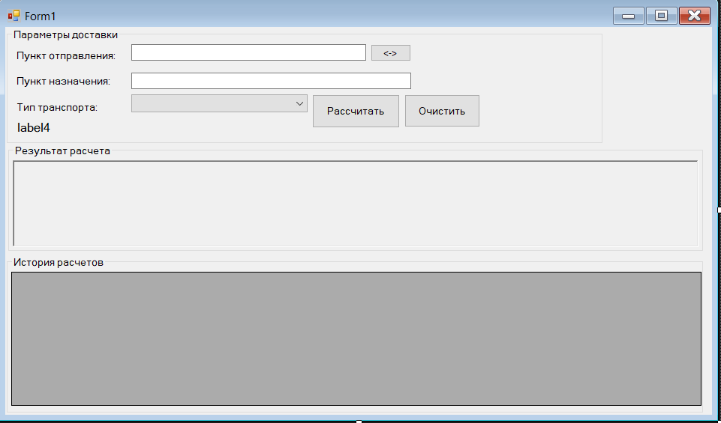
- Код
Form1
using System;
using System.Collections.Generic;
using System.Drawing;
using System.Windows.Forms;

namespace DeliveryCostCalculator
{
public partial class Form1 : Form
{
private DeliveryService _deliveryService;
private List<RouteInfo> _history;
private BindingSource _historyBindingSource;

public Form1()
{
InitializeComponent();
InitializeService();
SetupHistoryGrid();
LoadTransportTypes();
AttachEvents();
SetStatus("Готов", Color.Orange);
}

private void InitializeService()
{
_deliveryService = new DeliveryService();

_deliveryService.ErrorOccurred += (s, msg) =>
{
if (InvokeRequired)
Invoke(new Action(() => MessageBox.Show(msg, "Ошибка",
MessageBoxButtons.OK, MessageBoxIcon.Error)));
else
MessageBox.Show(msg, "Ошибка", MessageBoxButtons.OK, MessageBoxIcon.Error);
};

_deliveryService.StatusChanged += (s, msg) =>
{
if (InvokeRequired)
Invoke(new Action(() => UpdateStatus(msg)));
else
UpdateStatus(msg);
};
}

private void SetupHistoryGrid()
{
_history = new List<RouteInfo>();
_historyBindingSource = new BindingSource { DataSource = _history };

dgvHistory.AutoGenerateColumns = false;
dgvHistory.Columns.Clear();

dgvHistory.Columns.Add(new DataGridViewTextBoxColumn
{
DataPropertyName = "FromAddress",
HeaderText = "Откуда",
Width = 150
});
dgvHistory.Columns.Add(new DataGridViewTextBoxColumn
{
DataPropertyName = "ToAddress",
HeaderText = "Куда",
Width = 150
});
dgvHistory.Columns.Add(new DataGridViewTextBoxColumn
{
DataPropertyName = "DistanceKm",
HeaderText = "Расстояние (км)",
Width = 80,
DefaultCellStyle = new DataGridViewCellStyle { Format = "F1" }
});
dgvHistory.Columns.Add(new DataGridViewTextBoxColumn
{
DataPropertyName = "Cost",
HeaderText = "Стоимость (руб)",
Width = 80,
DefaultCellStyle = new DataGridViewCellStyle { Format = "F2" }
});
dgvHistory.Columns.Add(new DataGridViewTextBoxColumn
{
DataPropertyName = "TransportType",
HeaderText = "Транспорт",
Width = 80
});
dgvHistory.Columns.Add(new DataGridViewTextBoxColumn
{
DataPropertyName = "CalculationTime",
HeaderText = "Время расчета",
Width = 120,
DefaultCellStyle = new DataGridViewCellStyle { Format = "dd.MM.yyyy HH:mm" }
});

dgvHistory.DataSource = _historyBindingSource;
}

private void LoadTransportTypes()
{
cmbTransport.DisplayMember = "ToString";
cmbTransport.DataSource = _deliveryService.GetTransportRates();
}

private void AttachEvents()
{
btnCalculate.Click += BtnCalculate_Click;
btnClear.Click += BtnClear_Click;
btnSwap.Click += BtnSwap_Click;
dgvHistory.CellDoubleClick += DgvHistory_CellDoubleClick;
}

private void SetStatus(string text, Color color)
{
if (lblStatus.InvokeRequired)
{
lblStatus.Invoke(new Action(() =>
{
lblStatus.Text = text;
lblStatus.ForeColor = color;
}));
}
else
{
lblStatus.Text = text;
lblStatus.ForeColor = color;
}
}

private async void BtnCalculate_Click(object sender, EventArgs e)
{
if (string.IsNullOrWhiteSpace(txtFrom.Text) || string.IsNullOrWhiteSpace(txtTo.Text))
{
MessageBox.Show("Заполните поля 'Откуда' и 'Куда'", "Ошибка ввода",
MessageBoxButtons.OK, MessageBoxIcon.Warning);
return;
}

if (cmbTransport.SelectedItem == null)
{
MessageBox.Show("Выберите тип транспорта", "Ошибка ввода",
MessageBoxButtons.OK, MessageBoxIcon.Warning);
return;
}

btnCalculate.Enabled = false;
btnSwap.Enabled = false;
SetStatus("Выполняется расчет...", Color.DodgerBlue);

try
{
string transportType = (cmbTransport.SelectedItem as TransportRate)?.Name ?? "Автомобиль";

var result = await _deliveryService.CalculateDeliveryAsync(
txtFrom.Text.Trim(),
txtTo.Text.Trim(),
transportType);

if (result != null)
{
DisplayResult(result);
_history.Add(result);
_historyBindingSource.ResetBindings(false);
if (_history.Count > 0)
dgvHistory.FirstDisplayedScrollingRowIndex = _history.Count - 1;
SetStatus("Расчет выполнен успешно", Color.Green);
}
else
{
SetStatus("Готов", Color.Orange);
}
}
catch (Exception ex)
{
MessageBox.Show($"Ошибка: {ex.Message}", "Ошибка",
MessageBoxButtons.OK, MessageBoxIcon.Error);
SetStatus("Готов", Color.Orange);
}
finally
{
btnCalculate.Enabled = true;
btnSwap.Enabled = true;
}
}

private void BtnSwap_Click(object sender, EventArgs e)
{
string temp = txtFrom.Text;
txtFrom.Text = txtTo.Text;
txtTo.Text = temp;
rtbResult.Clear();
SetStatus("Готов", Color.Orange);
}

private void BtnClear_Click(object sender, EventArgs e)
{
txtFrom.Clear();
txtTo.Clear();
if (cmbTransport.Items.Count > 0)
cmbTransport.SelectedIndex = 0;
rtbResult.Clear();
SetStatus("Готов", Color.Orange);
}

private void DgvHistory_CellDoubleClick(object sender, DataGridViewCellEventArgs e)
{
if (e.RowIndex >= 0 && e.RowIndex < _history.Count)
{
var route = _history[e.RowIndex];
txtFrom.Text = route.FromAddress;
txtTo.Text = route.ToAddress;

foreach (TransportRate rate in cmbTransport.Items)
{
if (rate.Name == route.TransportType)
{
cmbTransport.SelectedItem = rate;
break;
}
}

DisplayResult(route);
SetStatus("Готов", Color.Orange);
}
}

private void DisplayResult(RouteInfo route)
{
rtbResult.Clear();

rtbResult.SelectionFont = new Font("Arial", 12, FontStyle.Bold);
rtbResult.SelectedText = "РЕЗУЛЬТАТ РАСЧЕТА\r\n\r\n";

rtbResult.SelectionFont = new Font("Arial", 10, FontStyle.Regular);
rtbResult.SelectedText = $"Откуда: {route.FromAddress}\r\n";
rtbResult.SelectedText = $"Координаты: {route.FromCoords}\r\n";
rtbResult.SelectedText = $"Куда: {route.ToAddress}\r\n";
rtbResult.SelectedText = $"Координаты: {route.ToCoords}\r\n";
rtbResult.SelectedText = $"Транспорт: {route.TransportType}\r\n\r\n";

rtbResult.SelectionFont = new Font("Arial", 10, FontStyle.Bold);
rtbResult.SelectedText = $"Расстояние: {route.DistanceKm:F1} км\r\n";
rtbResult.SelectedText = $"Время в пути: {FormatDuration(route.DurationHours)}\r\n";
rtbResult.SelectedText = $"Стоимость доставки: {route.Cost:F2} руб.\r\n\r\n";

rtbResult.SelectionFont = new Font("Arial", 8, FontStyle.Italic);
rtbResult.SelectedText = $"Рассчитано: {route.CalculationTime:dd.MM.yyyy HH:mm:ss}";
}

private string FormatDuration(double hours)
{
int totalMinutes = (int)(hours * 60);
int h = totalMinutes / 60;
int m = totalMinutes % 60;

if (h > 0 && m > 0)
return $"{h} ч {m} мин";
else if (h > 0)
return $"{h} ч";
else
return $"{m} мин";
}

private void UpdateStatus(string message)
{
rtbResult.SelectionColor = Color.Gray;
rtbResult.SelectionFont = new Font("Arial", 8, FontStyle.Italic);
rtbResult.SelectedText = $"> {message}\r\n";
}
}
}
Services.cs
using System;
using System.Collections.Generic;
using System.Globalization;
using System.IO;
using System.Net;
using System.Threading.Tasks;
using System.Web.Script.Serialization;

namespace DeliveryCostCalculator
{
public class DeliveryService
{
private readonly JavaScriptSerializer _jsonSerializer;
private readonly List<TransportRate> _transportRates;
private readonly Dictionary<string, Coordinates> _cityDatabase;

private readonly string _userAgent = "Mozilla/5.0 (Windows NT 10.0; Win64; x64) AppleWebKit/537.36";
private DateTime _lastRequest = DateTime.MinValue;

public event EventHandler<string> ErrorOccurred;
public event EventHandler<string> StatusChanged;

public DeliveryService()
{
_jsonSerializer = new JavaScriptSerializer();
_transportRates = new List<TransportRate>
{
new TransportRate { Name = "Автомобиль", RatePerKm = 40, SpeedKmh = 60 },
new TransportRate { Name = "Грузовик", RatePerKm = 60, SpeedKmh = 50 },
new TransportRate { Name = "Мотоцикл", RatePerKm = 25, SpeedKmh = 70 }
};

_cityDatabase = new Dictionary<string, Coordinates>(StringComparer.OrdinalIgnoreCase)
{
{ "москва", new Coordinates { Latitude = 55.7558, Longitude = 37.6173 } },
{ "moscow", new Coordinates { Latitude = 55.7558, Longitude = 37.6173 } },
{ "красная площадь", new Coordinates { Latitude = 55.7536, Longitude = 37.6215 } },

{ "санкт-петербург", new Coordinates { Latitude = 59.9343, Longitude = 30.3351 } },
{ "питер", new Coordinates { Latitude = 59.9343, Longitude = 30.3351 } },
{ "spb", new Coordinates { Latitude = 59.9343, Longitude = 30.3351 } },
{ "невский проспект", new Coordinates { Latitude = 59.9343, Longitude = 30.3351 } },

{ "казань", new Coordinates { Latitude = 55.8304, Longitude = 49.0661 } },
{ "kazan", new Coordinates { Latitude = 55.8304, Longitude = 49.0661 } },

{ "екатеринбург", new Coordinates { Latitude = 56.8389, Longitude = 60.6057 } },
{ "ekb", new Coordinates { Latitude = 56.8389, Longitude = 60.6057 } },

{ "новосибирск", new Coordinates { Latitude = 55.0084, Longitude = 82.9357 } },
{ "nsk", new Coordinates { Latitude = 55.0084, Longitude = 82.9357 } },
{ "красный проспект", new Coordinates { Latitude = 55.0415, Longitude = 82.9346 } },

{ "нижний новгород", new Coordinates { Latitude = 56.2965, Longitude = 43.9361 } },
{ "nnov", new Coordinates { Latitude = 56.2965, Longitude = 43.9361 } },

{ "самара", new Coordinates { Latitude = 53.2415, Longitude = 50.2212 } },
{ "samara", new Coordinates { Latitude = 53.2415, Longitude = 50.2212 } },

{ "ростов-на-дону", new Coordinates { Latitude = 47.2357, Longitude = 39.7015 } },
{ "rostov", new Coordinates { Latitude = 47.2357, Longitude = 39.7015 } },

{ "сочи", new Coordinates { Latitude = 43.6028, Longitude = 39.7342 } },
{ "sochi", new Coordinates { Latitude = 43.6028, Longitude = 39.7342 } },
{ "курортный проспект", new Coordinates { Latitude = 43.5855, Longitude = 39.7303 } },

{ "владивосток", new Coordinates { Latitude = 43.1155, Longitude = 131.8855 } },
{ "vladivostok", new Coordinates { Latitude = 43.1155, Longitude = 131.8855 } }
};
}

public List<TransportRate> GetTransportRates() => _transportRates;

public async Task<Coordinates> GeocodeAddressAsync(string address)
{
if (string.IsNullOrWhiteSpace(address))
{
OnErrorOccurred("Адрес не может быть пустым");
return null;
}

if (TryParseCoordinates(address, out Coordinates coords))
{
OnStatusChanged($"Распознаны координаты: {coords}");
return coords;
}

string lowerAddress = address.ToLower().Trim();
foreach (var kvp in _cityDatabase)
{
if (lowerAddress.Contains(kvp.Key))
{
OnStatusChanged($"Найдено в базе: {kvp.Value}");
return kvp.Value;
}
}

OnStatusChanged($"Поиск через API: {address}");

try
{
var timeSinceLast = DateTime.Now - _lastRequest;
if (timeSinceLast.TotalSeconds < 1)
{
await Task.Delay(1000 - (int)timeSinceLast.TotalMilliseconds);
}

string encodedAddress = Uri.EscapeDataString(address);
string url = $"https://nominatim.openstreetmap.org/search?q={encodedAddress}&format=json&limit=1";

var request = (HttpWebRequest)WebRequest.Create(url);
request.Method = "GET";
request.UserAgent = _userAgent;
request.Headers.Add("Accept-Language", "ru");
request.Timeout = 10000;

_lastRequest = DateTime.Now;

using (var response = await Task.Factory.FromAsync<WebResponse>(
request.BeginGetResponse, request.EndGetResponse, null))
using (var stream = response.GetResponseStream())
using (var reader = new StreamReader(stream))
{
string json = await reader.ReadToEndAsync();
var results = _jsonSerializer.Deserialize<object[]>(json);

if (results != null && results.Length > 0)
{
var first = results[0] as Dictionary<string, object>;
if (first != null)
{
double lat = Convert.ToDouble(first["lat"], CultureInfo.InvariantCulture);
double lon = Convert.ToDouble(first["lon"], CultureInfo.InvariantCulture);

OnStatusChanged($"Найдены координаты: {lat:F4}, {lon:F4}");
return new Coordinates { Latitude = lat, Longitude = lon };
}
}

OnErrorOccurred($"Адрес не найден: {address}");
}
}
catch (Exception ex)
{
OnErrorOccurred($"Ошибка геокодирования: {ex.Message}");
}

return null;
}

public async Task<RouteInfo> BuildRouteAsync(Coordinates from, Coordinates to, string transportType)
{
if (from == null || to == null)
{
OnErrorOccurred("Координаты не могут быть null");
return null;
}

OnStatusChanged($"Поиск маршрута через GraphHopper...");

try
{
string fromStr = $"{from.Latitude.ToString(CultureInfo.InvariantCulture)},{from.Longitude.ToString(CultureInfo.InvariantCulture)}";
string toStr = $"{to.Latitude.ToString(CultureInfo.InvariantCulture)},{to.Longitude.ToString(CultureInfo.InvariantCulture)}";

string url = $"https://graphhopper.com/api/1/route?point={fromStr}&point={toStr}&vehicle=car&key=&locale=ru";

var request = (HttpWebRequest)WebRequest.Create(url);
request.Method = "GET";
request.UserAgent = _userAgent;
request.Timeout = 15000;

using (var response = await Task.Factory.FromAsync<WebResponse>(
request.BeginGetResponse, request.EndGetResponse, null))
using (var stream = response.GetResponseStream())
using (var reader = new StreamReader(stream))
{
string json = await reader.ReadToEndAsync();
var result = _jsonSerializer.Deserialize<Dictionary<string, object>>(json);

if (result != null && result.ContainsKey("paths"))
{
var paths = result["paths"] as object[];
if (paths != null && paths.Length > 0)
{
var firstPath = paths[0] as Dictionary<string, object>;
if (firstPath != null)
{
double distance = Convert.ToDouble(firstPath["distance"]) / 1000.0;
double time = Convert.ToDouble(firstPath["time"]) / 1000.0 / 3600.0;

TransportRate selectedTransport = _transportRates.Find(t => t.Name == transportType)
?? _transportRates[0];

double cost = distance * selectedTransport.RatePerKm;

OnStatusChanged($"Маршрут построен: {distance:F1} км");

return new RouteInfo
{
DistanceKm = distance,
DurationHours = time,
FromCoords = from,
ToCoords = to,
TransportType = transportType,
Cost = cost,
CalculationTime = DateTime.Now
};
}
}
}
}
}
catch (Exception ex)
{
OnStatusChanged($"Ошибка GraphHopper: {ex.Message}. Использую прямое расстояние.");
}

return CalculateDirectRoute(from, to, transportType);
}

private RouteInfo CalculateDirectRoute(Coordinates from, Coordinates to, string transportType)
{
double distance = CalculateDistance(from, to);

TransportRate selectedTransport = _transportRates.Find(t => t.Name == transportType)
?? _transportRates[0];

double duration = distance / selectedTransport.SpeedKmh;
double cost = distance * selectedTransport.RatePerKm;

OnStatusChanged($"Использовано прямое расстояние: {distance:F1} км");

return new RouteInfo
{
DistanceKm = distance,
DurationHours = duration,
FromCoords = from,
ToCoords = to,
TransportType = transportType,
Cost = cost,
CalculationTime = DateTime.Now
};
}

private double CalculateDistance(Coordinates from, Coordinates to)
{
double R = 6371; // Радиус Земли в км

double lat1 = from.Latitude * Math.PI / 180;
double lat2 = to.Latitude * Math.PI / 180;
double deltaLat = (to.Latitude - from.Latitude) * Math.PI / 180;
double deltaLon = (to.Longitude - from.Longitude) * Math.PI / 180;

double a = Math.Sin(deltaLat / 2) * Math.Sin(deltaLat / 2) +
Math.Cos(lat1) * Math.Cos(lat2) *
Math.Sin(deltaLon / 2) * Math.Sin(deltaLon / 2);

double c = 2 * Math.Atan2(Math.Sqrt(a), Math.Sqrt(1 - a));

return R * c;
}

public async Task<RouteInfo> CalculateDeliveryAsync(string fromInput, string toInput, string transportType)
{
OnStatusChanged("Начинаем расчет...");

var fromCoords = await GeocodeAddressAsync(fromInput);
if (fromCoords == null)
{
OnErrorOccurred($"Не удалось определить координаты для: {fromInput}");
return null;
}

var toCoords = await GeocodeAddressAsync(toInput);
if (toCoords == null)
{
OnErrorOccurred($"Не удалось определить координаты для: {toInput}");
return null;
}

var route = await BuildRouteAsync(fromCoords, toCoords, transportType);
if (route != null)
{
route.FromAddress = fromInput;
route.ToAddress = toInput;
}

return route;
}

private double GetRateForTransport(string transportType)
{
foreach (var rate in _transportRates)
if (rate.Name == transportType) return rate.RatePerKm;
return 40;
}

private bool TryParseCoordinates(string input, out Coordinates coords)
{
coords = null;
if (string.IsNullOrWhiteSpace(input)) return false;

try
{
string[] parts = input.Split(new[] { ',', ' ', ';' }, StringSplitOptions.RemoveEmptyEntries);
if (parts.Length >= 2)
{
string latStr = parts[0].Trim().Replace(',', '.');
string lonStr = parts[1].Trim().Replace(',', '.');

if (double.TryParse(latStr, NumberStyles.Any, CultureInfo.InvariantCulture, out double lat) &&
double.TryParse(lonStr, NumberStyles.Any, CultureInfo.InvariantCulture, out double lon))
{
if (lat >= -90 && lat <= 90 && lon >= -180 && lon <= 180)
{
coords = new Coordinates { Latitude = lat, Longitude = lon };
return true;
}
}
}
}
catch { }

return false;
}

protected virtual void OnErrorOccurred(string message)
=> ErrorOccurred?.Invoke(this, message);

protected virtual void OnStatusChanged(string message)
=> StatusChanged?.Invoke(this, message);
}
} Models.cs
using System;

namespace DeliveryCostCalculator
{
public class Coordinates
{
public double Latitude { get; set; }
public double Longitude { get; set; }

public override string ToString()
{
return $"{Latitude:F4}, {Longitude:F4}";
}
}

public class RouteInfo
{
public double DistanceKm { get; set; }
public double DurationHours { get; set; }
public string FromAddress { get; set; }
public string ToAddress { get; set; }
public Coordinates FromCoords { get; set; }
public Coordinates ToCoords { get; set; }
public string TransportType { get; set; }
public double Cost { get; set; }
public DateTime CalculationTime { get; set; } = DateTime.Now;
}

public class TransportRate
{
public string Name { get; set; }
public double RatePerKm { get; set; }
public double SpeedKmh { get; set; }

public override string ToString()
{
return $"{Name} ({RatePerKm} руб./км)";
}
}
}
- Тест
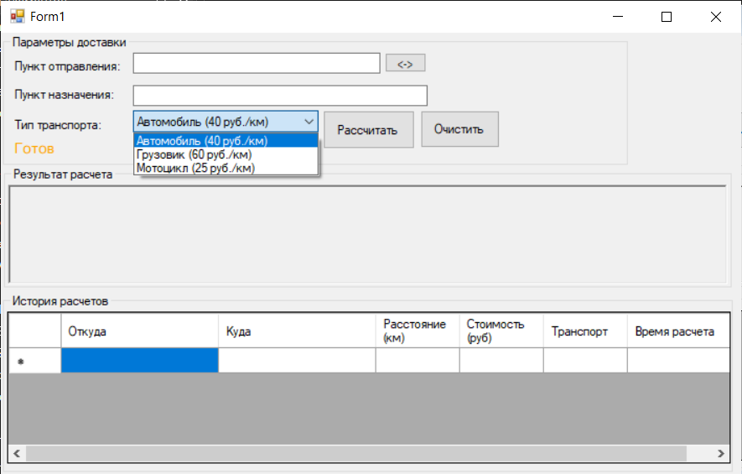
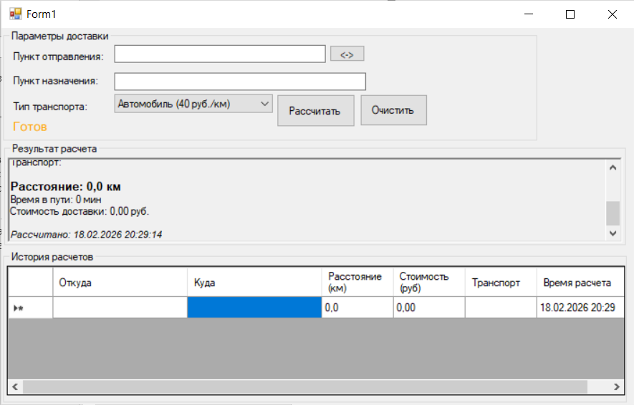
При взаимодействии с dgvHistory
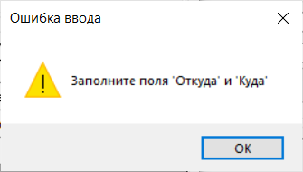
При нажатии рассчитать пустые данные
